Big Data Class Activity 4 (Group 2)
Bansil Patel
Sakshi Oberoi
Akshitha Ralla
Rachit Bhatt
Harsh Mohile

ETL TOOLS
1. Hadoop:
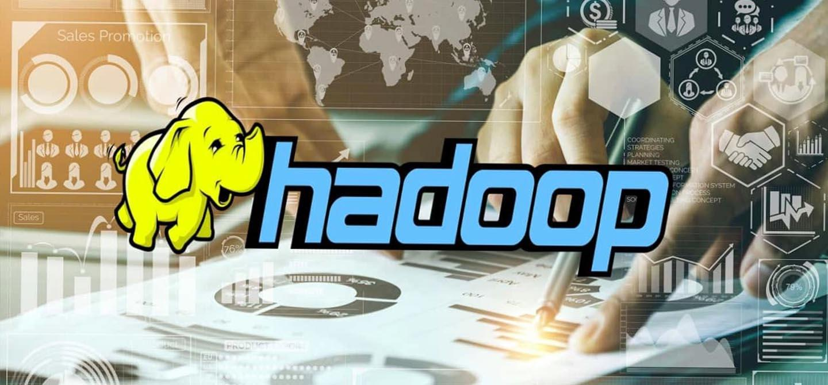
What is Hadoop?
- Large datasets can be processed and stored distributed using the Hadoop open-source framework. It is widely used in the big data industry and is a component of the projects of the Apache Software Foundation. A dependable, scalable, and fault-tolerant ecosystem for processing and storing enormous volumes of data across clusters of commodity hardware is offered by Hadoop.

Advantages:
- Economical: It is an open-source software, usually runs on commodity hardware and therefore the expenses for data storage and processing are very low i.e., cost-effective in comparison to traditional databases and data warehousing solutions, making a wide range of accessibility for big data analytics.
- Fault Tolerance: Ensures reliability and uninterrupted processing of data. It processes the data using the already existing copies and replicates the data for multiple nodes in HDFS. This feature acts for hardware failures and allows the data for the delivery of high-level processing.
- Scalability: It is engineered for horizontal scaling, which helps the organizations to work with large voluminous data and add nodes as per their requirements. Useful for large-scale data preprocessing. The clustered data which is distributed finely can ensure that the organizations can add their own nodes for the growth.
Disadvantages:
- Learning curve: Soon, newcomers to this technology might find it difficult to learn, write and manage Hadoop jobs. It relies on data locality where data works more efficiently when it is run on the same node. This requires cluster management to tackle performance issues.
- Complexity: Hadoop clusters require a proper setting up and configuration which can be handled by an efficient team of skilled personnel as it is a complex task when it comes to the organizations which are new to big data technologies. This generally increases the operational cost.
- Limited real-time processing: The latency of Hadoop's batch processing can be high as it is not suitable for real-time or collaborative data management. Majorly designed for long running jobs and high throughput. Here Hadoop cannot be considered as the best choice and therefore other technologies like Apache Spark might be more suitable.
Conclusion:
- To sum up, Hadoop has definitely transformed the big data analytics and processing space. Its distributed file system offers a scalable and economical way to handle large datasets when combined with the MapReduce programming methodology. Hadoop is a key component of the big data ecosystem because of its capacity to handle and store a wide variety of data types.
- However, as technology advances, substitute approaches and frameworks—like Apache Spark—have become more well-liked because of their enhanced usability and performance. For real-time data processing needs, Hadoop's batch processing approach might not be the most effective. Hadoop is still a useful tool for businesses handling large-scale data analytics and storage in spite of these difficulties.

2. Google Cloud Dataflow:
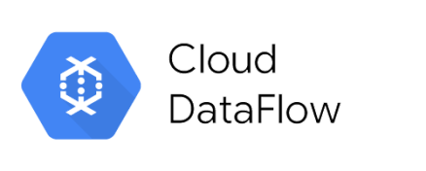
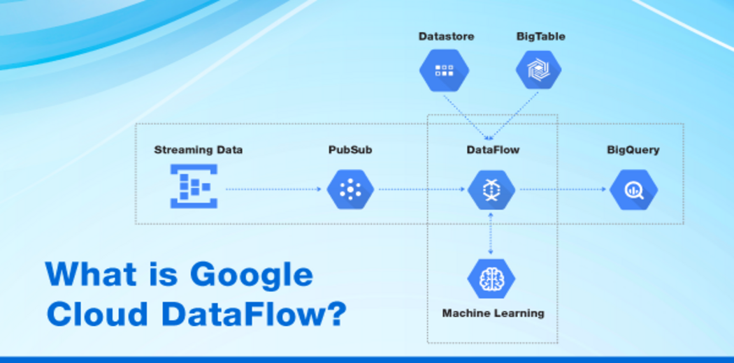

What is Google Cloud Dataflow?
- Google Cloud Platform offers Google Cloud Dataflow, a fully managed solution for batch and stream data processing. Its purpose is to make pipeline construction and implementation for data processing easier. The foundation of Google Cloud Dataflow is Apache Beam, an open-source, unified batch and stream processing paradigm.

Advantages:
- Real-time processing: This supports both stream and batch processing. It is flexible to handle the data with huge variations. Activation with machine learning and data streaming which fully manages data processing service by building hybrid pipelines and making it easier. Manages the community-driven innovation using Apache Beam SDK
- Serverless: The infrastructure can be fully managed by Google and we need not be precise with the scaling, provisioning, and maintenance as it is a serverless service. Cost-efficient and there is no specific need for cluster management. Focuses on data processing logic.
- Integrating the ecosystem: It provided a cohesive environment for storage, analysis, and data processing by the creating of pipelines for machine learning workflows. The Dataflow can easily integrate with other services like Big Query, Pub/Sub, Cloud Storage and many more.
Disadvantages:
- Cost-Sensitive: As the Dataflows are serverless, it can be considered as cost-effective, but the pricing patterns can have major deviations if they are not managed or monitored precisely. Unexpected expenses by the organizations should be planned carefully or simply avoided.
- Complexity: The learning-curve of programming model for the developers who are new to this batch data processing can be a bit difficult as this requires specialised knowledge. This curve due to complexities can slow down the development process.
- Limitations on flexibility: Deep integration can be a challenge for the organizations as attaining vendor-agnostic solutions by vendor lock-in condition is not so easy task as it sets few limitations on data flexibility for changing business needs.
Conclusion:
- At the end of the Google Cloud Dataflow study, it is clear that the platform offers a robust and fully managed solution for data flow and batch processing. Using Apache Beamand#039's unified programming model, Dataflow provides a scalable and efficient environment for building data pipelines. Serverless architecture eliminates the need for infrastructure management, allowing users to focus on computing logic.

3. Spark:
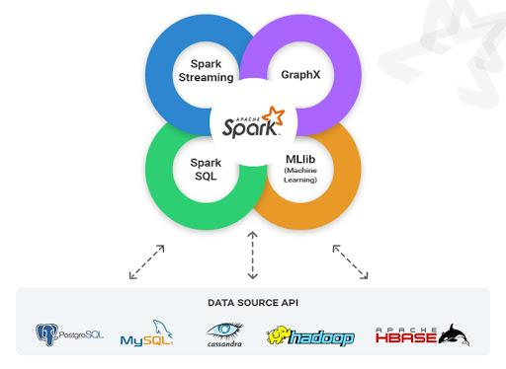

What is Apache spark?
- An open-source distributed computing platform called Apache Spark is made for handling and analyzing large amounts of data. It offers a sophisticated and adaptable data processing engine with support for interactive queries, streaming analytics, machine learning, and batch processing. The speed, usability, and versatility of Apache Spark, a member of the Apache Software Foundation, have made it quite popular in the big data environment.
Advantages:
- Facility of development: The user-oriented and easily approachable development environment is offered by Spark through upper-level APIs in languages like Python, R, Scala, and Java. It contributes to uninterrupted experience of development.
- Live-Stream data processing: Spark’s capabilities of streaming real time data enable the processing of data in an unbroken flow allowing immediate analysis at the point of its arrival which provides instant insights. Thus, contributing quick and effective decision making based on updated information.
- Fault tolerant: Spark handles fault management through the utilization of mechanisms referred as lineage information and RDDs (resilient distributed datasets). Each distributed dataset recalls the changes applied to the parent RDDs, and the information is known as lineage. This can be used to reconstruct the data if a node fails to work during the processing.
Disadvantages:
- Sharp hardware costs: Managing Spark on an extensive scale leads to soaring hardware expenses, especially while the processing of big data. So, this can be a consideration for organizations as per their budget constraints.
- Compatibility issues: The various updates and alterations in the versions of Spark give rise to compatibility challenges with the code that already exists in the system. This necessitates extra effort for the migration along with the maintenance.
- Ineffective support to complex ETL workflows: The tools used in Spark might not be fit for managing the dependencies of various stages of complex workflows of ETL. Some tools may be proved efficient in data processing but not be suitable for dealing with the challenges caused by intricate workflows.
Conclusion:
- In summary, Spark makes it easier to handle large amounts of organized and unstructured data, either in real time or in the past, by seamlessly integrating pertinent sophisticated features like graph algorithms and machine learning.

4. StreamSets:
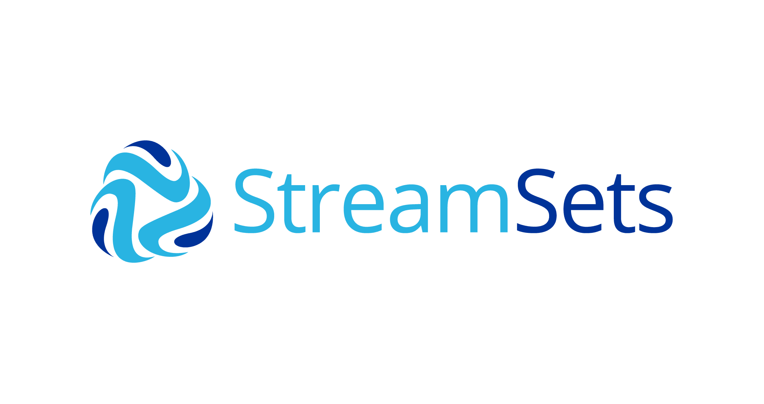
What is streamSets?
- A platform for data integration called StreamSets makes it possible to create, run, and keep track of data pipelines that are used to transfer and modify data between different systems. It is used by both developers and data engineers due to its graphical interface for designing, deploying, and managing data workflows.
Advantages:
- User-convenient interface: StreamSets provides a feasible and intuitive environment for users which makes it easy for both programmers and engineers to create and maintain the ETL pipelines.
- Visual designing for Dataflow: This feature of StreamSets allows the drag and drop functionality for components onto a canvas which represent different stages of the process of ETL. Further, the graphical representation provides a clear visualised view of entire pipeline of data. The live visualization helps to identify issues more precisely and is beneficial for debugging.
- Scalability: StreamSets basically shaped for parallel scalability, are able to handle large amounts of data by introducing extra resources into the cluster. This thing is essential for managing rising data requirements.

Disadvantages:
- Resource intensiveness: Particularly in the case of dealing with complex transformations for data of large volumes, StreamSets might require substantial resources. These can be hardware requirements which includes capacities of CPU, ample memory and effective storage systems as well as scalability planning resulting in increased costs.
- Dependent on external systems: StreamSets lean on exterior systems for the storage of configurations, history of executing and metadata. Any external troubles can have adverse effects on its functionality.
- Integration issues through legacy systems: Assimilating StreamSets with Legacy environments having outmoded technologies may be a cause to some challenges as it can lead to compatibility issues. Hence, the requirement of added efforts for consistent integration.
Conclusion:
- It becomes clear that StreamSets is a reliable and adaptable option for data integration and transfer. Because of its intuitive interface and ability to stream data in real time, it is the top option for businesses looking to streamline their ETL procedures. The platform's popularity is influenced by its broad range of integration possibilities, convenience of use, and capacity to manage a variety of data sources. However, before implementing StreamSets ETL for their applications, customers must take into account unique requirements and scalability considerations. All things considered, the platform sticks out as a promising instrument in the constantly changing field of data engineering and ETL solutions.

5. Apache NiFi:
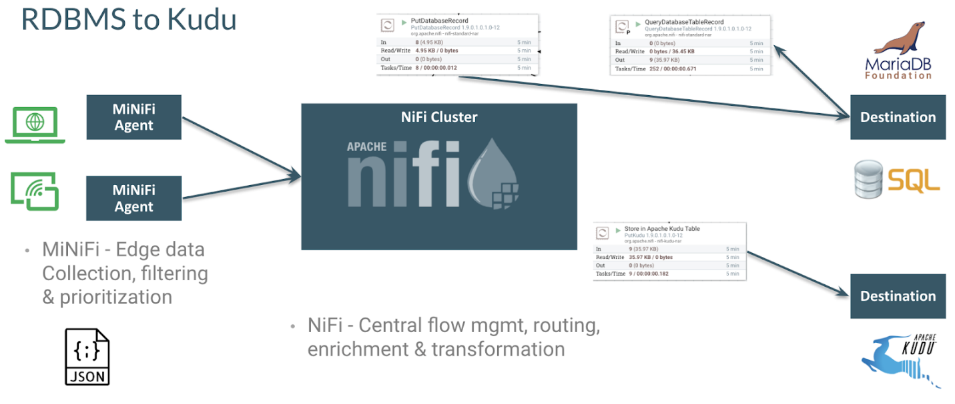

What is Apache NiFi?
- The web-based interface of Apache NiFi, an open-source data integration tool, allows for the construction, management, and observation of data flows. The National Security Agency (NSA) developed it, and the Apache Software Foundation eventually made it open-source. NiFi is made to automate data transfer across systems, which facilitates real-time data collection, processing, and distribution.
Advantages:
- Data extraction and origin: It can trace the provenance and transformations of data while going through the comprehensive data. This part plays a crucial role for auditing, data governing and troubleshooting. With this we can attain a better quality, security, data flow, and visibility of data.
- User- Friendly: It has a web-based interface which allows the users to configure, design, monitor data flows through drag and drop interface. The approach eases the creation of difficult data integration pipelines and lessens the need of complex coding by visualising data flow effectively.
- Extensibility: Integration is done to perfection for huge and various data destinations. A huge range of controller services, processors, and extensions are used to connect to various devices and perform data transformations.
Disadvantages:
- Customization issues: With the wide variety of processors along with the components being provided by Apache NiFi, customization or the introduction of custom designed processors becomes challenging for the programmers not having strong programming skills.
- Security Complexity: Arranging security features in it, like SSL, access controls and encryption demands careful attention. Improper configurations can cause risks to the privacy and integrity of data.
- Narrow advanced analytics: Apache NiFi is basically projected for integration of data and its flow management. It might not possess the capabilities for advanced analytics in the particular tools for complex analysis and machine learning.
Conclusion:
- In summary, the research conducted by Apache NiFi clearly shows that NiFi is a unique and strong instrument for flow management, automation, and data integration. Its broad range of processors and interfaces, together with its user-friendly interface, enable smooth data transfer between different systems. The platform is appealing because of its emphasis on data provenance, security features, and extensibility; these attributes make it appropriate for data operations at the enterprise level as well as smaller initiatives.

Comparison of 5 above mentioned ETL tools:
CHARACTERISTICS | Hadoop | StreamSet | Spark | Google Cloud Dataflow | Apache NiFi
TYPE | Big Data Computational Framework | ETL tool | Big data Framework | Control Stream and batch processing | Data assimilation and flow management
PROCESSING MODEL | Batch Processing Map-reduce | Batch and real time processing | Batch and real time processing | Stream and batch processing | Flow based data integration
USER FRIENDLINESS | Sharper learning curve | Instinctive visual design | Steeper learning curve (Scala, java) | Visual UI | Visual drag and drop functionality
FORM OF DATA | Batch processing | Batch and live streaming | Batch and live streaming | Streaming and Batch processing | Flow based real-time streaming
SCALIBILITY | Parallel Scaling | Cluster Deployment | Cluster of horizontal scaling | Automate scaling | Horizontal cluster deployment
ECOSYSTEM | Hadoop distributed file system | Extensive connectors | Spark Ecosystem (spark, SQL, etc) | Integrated with GCS sources | Broad communication
PROGRAMMING | Java Map-reduce | Visual design python | Scala, Python, Java | GO, Java, Python | Flow based programming
REAL-TIME | Limited capabilities | More capabilities for processing | More capabilities for processing | More capabilities for processing | More capabilities for Streaming
FAULT TOLERANCE | High | Checkpointing, retry mechanism | Resilient through lineage and RDDS | Automated recovery | Built-in failure mechanism
INTEGRATION | Integrates with some tools | Connectors for many data sources | Integrates with Hadoop and external system | Google cloud service integration | Better connectivity and flexibility
USE CASES | Storage of big data batch processing. | ETL, real-time | Batch and real-time batch processing | Steam and batch processing | Data integration and routine.

